Shattered Protocols Test Report 1.0, Unit test focus
Report covers the testing scope, test schedule, product features and quality, a list of all flags remaining open with a RISK assessment, and lessons learned.
Test Report Outline
- Project Title: Shattered Protocols
- Test Report Scope: Report on the increments 1, 2, 3 and 4 testing associated with release 1 and 2 testing, and system testing.
- Test team: Seth Welton
- Test Schedule:
  - System testing occurred 4 November 2024.
  - Iteration 1.1 will be done later in the week when bugs are addressed.
- Test Description: describe each test, what was tested and the test outcome.
a. Test specific keywords:
- help: Works. Typing ‘help’ displays use of keywords as well as giving extra tips on not using extraneous words like ‘please’ or ‘do.’
- north/up: Works.
- south/down: Works.
- east/right: Works.
- west/left: Works.
- exit: Works. Exits game.
b. Basic traversal of the game map using the north, south, east, and west keywords (no doors should be impassable (locked) at this stage):
- In game map lines up with Shattered Protocols Map Design:
-R0 = Front Desks: ‘south’, ‘east’, ‘west’: ‘You can’t go this way’ as expected.
‘north’: takes player to Meeting Room (R1) as expected.
-R1 = Meeting Room: ‘east’: ‘You can’t go this way’ as expected.
‘north’ takes player to Testing Lab (R4) as expected.
‘south’ takes player to Front Desks (R0) as expected.
‘west’ takes player to Development Lab (R2) as expected.
-R2 = Development Lab: ‘west’, ‘south’: ‘You can’t go this way’ as expected.
‘north’ takes player to Break Room (R5) as expected.
‘east’ takes player to Meeting Room (R1) as expected.
-R3 = Heart of Operations: ‘south’, ‘east’, ‘west’: ‘You can’t go this way’ as expected.
‘north’ takes player to Server Room (R6) as expected.
-R4 = Testing Lab: When in the Testing Lab (R4), keywords ‘north’ and ‘south’ take you to the Testing Lab (R4) instead of expected ‘north’: ‘can’t go this way’ and ‘south’: in Meeting Room (R1). Keywords ‘east’ and ‘west’ take you back and forth between Testing Lab (R4) and Break Room (R5) regardless of which room you started in and which direction (east or west) was inputted. The same issue with ‘east’ and ‘west’ for the Server Room (R6) as the user just goes back and forth. Oddly enough, you can break the cycle in the Testing Room (R6) or the Break Room (R5) by going ‘south.’ This bug however, makes the Server Room (R6) and Heart of Operations (R3) very difficult to access at this time. Sometimes east in Testing Lab (R4) allows access to Server Room (R6) if you play around enough with north and south first and then go east. This room is very buggy as the player gets stuck here a lot.
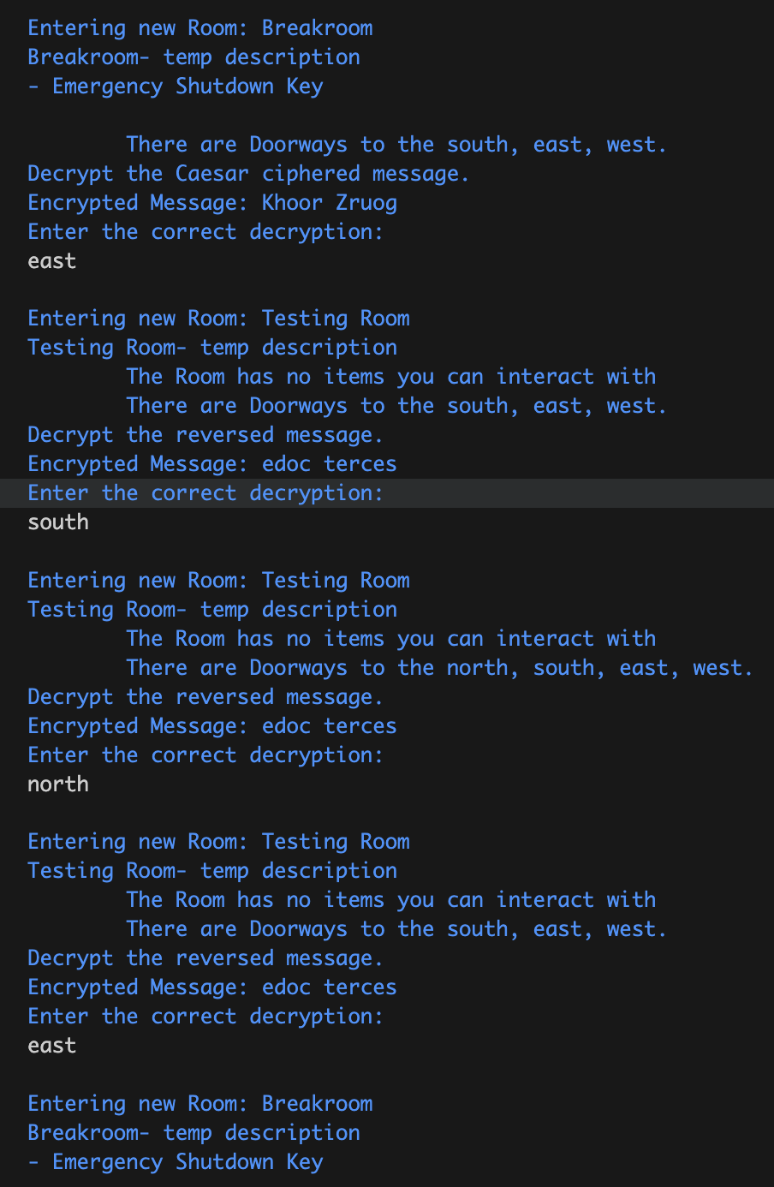
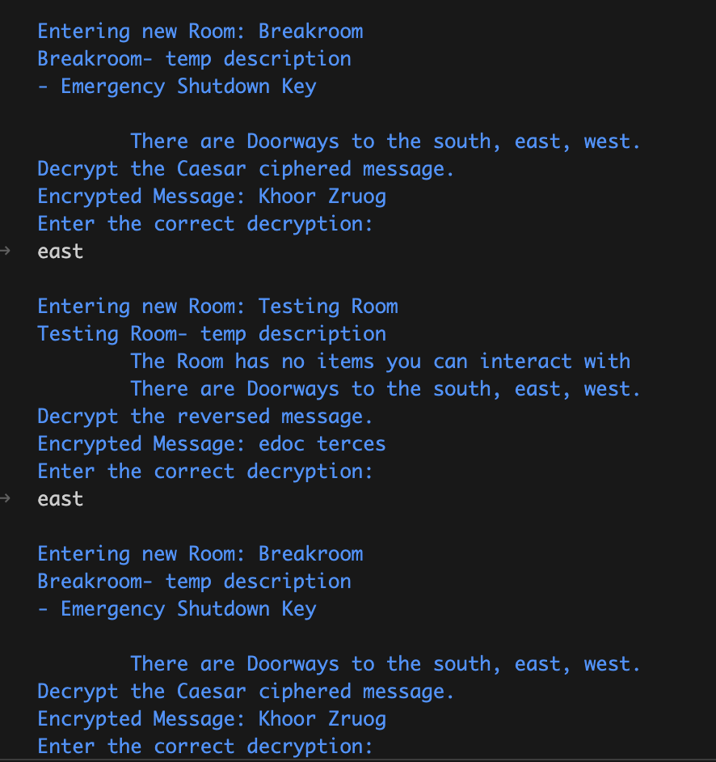
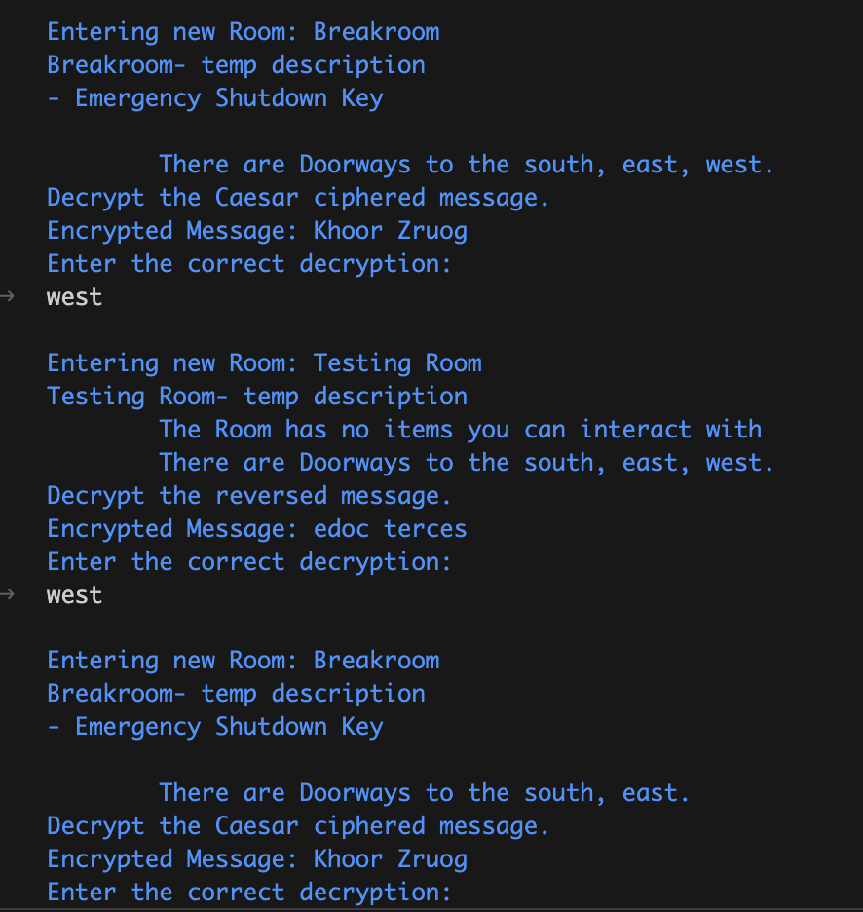

-R5 = Break Room: ‘north’: ‘You can’t go this way’ as expected (when not in loop with Testing Lab (R4)).
‘east’ and west bugged with Testing Lab (R4) as they both lead to Testing Lab (R4).
‘south’ takes player to Development Lab (R2) as expected.

-R6 = Server Room: ‘north’: ‘You can’t go this way’ as expected (when not in loop with Testing Lab (R4)).
‘east’ and west bugged with Testing Lab (R4) as they both lead to Testing Lab (R4).
‘south’ takes player to Heart of Operations (R3) as expected.

c. Solve the puzzles (with no expectation other than a “good job you solved it”).
- Try each room’s puzzle with correct input that will solve the puzzle:
-R0 = Front Desks, none.
-R1 = Meeting Room, Binary Lock Puzzle. “101010” inputted and ‘Correct! Puzzle solved’ appeared as expected.
-R2 = Development Lab, SQL Injection Puzzle. “' OR '1'='1 or 1'='1” inputted and ‘Correct! Puzzle solved’ appeared as expected.
-R3 = Heart of Operations, Password Cracker Puzzle. Cannot get this one to work. Hash for password does not work. Copy and paste of answer in code does not work.
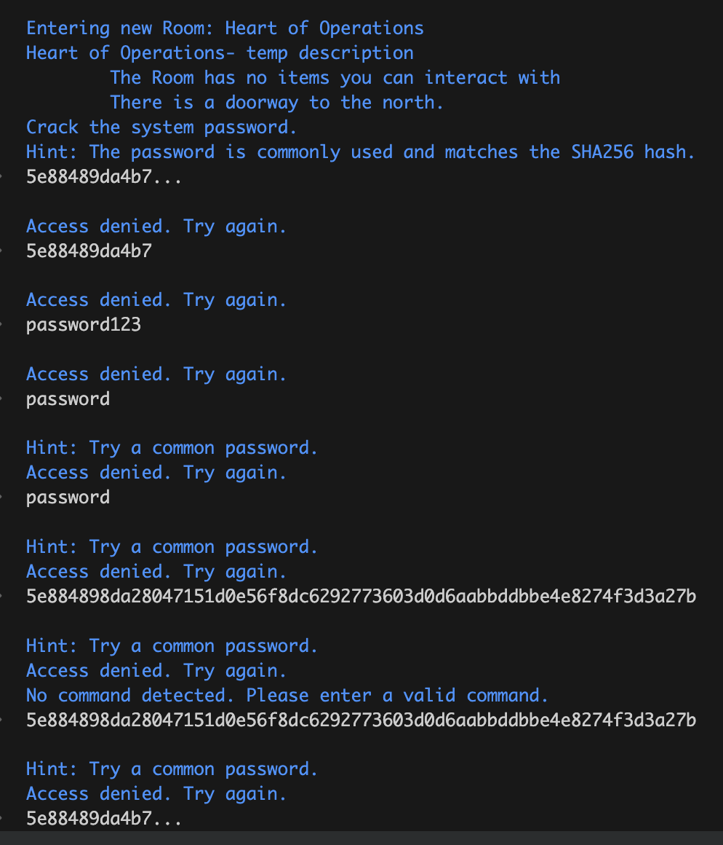
-R4 = Testing Lab, Reverse String Puzzle. “secret code” inputted and ‘Correct! Puzzle solved’ appeared as expected.
-R5 = Break Room, Caesar Cipher Puzzle. Variations of “Hello World” did not work.
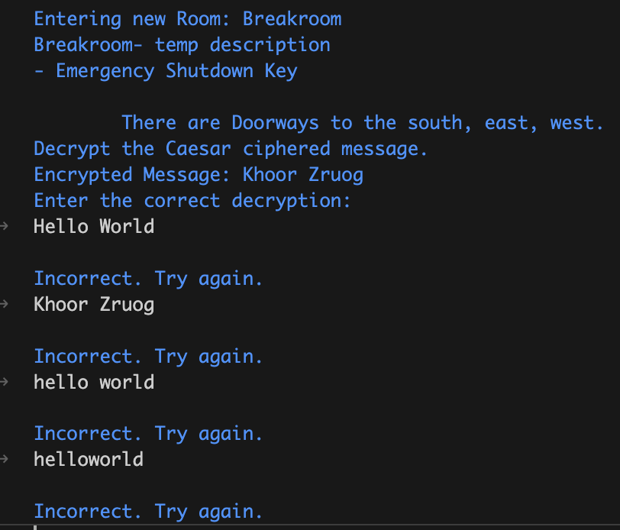
-R6 = Server Room, Code Injection Puzzle. “sudo firewall-bypass” inputted and ‘Correct! Puzzle solved’ appeared as expected.

- Try each room’s puzzle with incorrect input to fail the puzzle 10 times each.
-R0 = Front Desks, none.
-R1 = Meeting Room, Binary Lock Puzzle. 10 incorrect inputs correctly say “incorrect, try again” with try 3 and 5 giving hints as expected.
-R2 = Development Lab, SQL Injection Puzzle. 10 incorrect inputs correctly say “Access Denied. Try Again.” with try 3+ hints as expected.
-R3 = Heart of Operations, Password Cracker Puzzle. 10 incorrect inputs correctly say “Access denied. Try again”. Expected try 4+ to start giving hints, but it starts with 5+. Probably doesn’t matter, but odd.
-R4 = Testing Lab, Reverse String Puzzle. 10 incorrect inputs correctly say “incorrect, try again” with no hints included as expected.
-R5 = Break Room, Caesar Cipher Puzzle. 10 incorrect inputs correctly say “Incorrect. Try again” with no hints included as expected.
-R6 = Server Room, Code Injection Puzzle. 10 incorrect inputs correctly say “incorrect, try again” with try 3, 5, and 7+ giving hints as expected.

- Final product features and quality: describe the final product and any flaws

-When trying to solve a puzzle, if the player leaves the room and comes back to try to solve it again, the attemptCount does not reset. This could result in some hints getting buried and the user would be forced to scroll up on the history to try and find a previous hint instead of the puzzle just starting fresh.

- The puzzles need to be moved around so that the theme of the puzzle and the rooms could try to match. There is not supposed to be a puzzle in the Break Room (R5), just a key so that the puzzle in the Heart of Operations (R3) could be unlocked. There is supposed to be a puzzle in the Front Lobby (R0) to unlock entrance to the Meeting Room (R1).

-The Ceaser Cipher puzzle should say how many times the letters got shifted. In the code it is shifted by 3, but the user has no way of knowing which makes solving the puzzle a complete guess.

-Overall, the puzzles mostly work. At this stage, the fact that puzzles are mostly working is very good for us. Some of the rooms are lacking in hints, which can be fixed in the future and the Testing Room (R4) has some weird traversal bugs.

- Test Flags and Risk Management: List all open flaws/flags remaining and provide a RISK assessment for each
-Flaw: Navigation bugs in Testing Room (R4). Level of severity: High.
Risk assessment: This could impede the user experience as moving around becomes difficult. Since this is a text-based game, navigation cannot be confusing as there is no visual graphic for the user to rely on. The Testing Room (R4) is a well visited room as it is the connection to rooms R6 and R3. This could lead to possible frustration from the user.
-Flaw: Not all the puzzles work. Level of severity: Medium.
Risk assessment: At the moment, the puzzles not working is ok as these do not gatekeep any part of the rest of the game (so far). When the puzzles do act as locks to the doors in the future, the puzzles must work as intended or else progression in the game will not be possible. This could lead to dissatisfaction from the user as he/she will get stuck somewhere and the game will soft lock.
-Flaw: Not all puzzles have hints after a certain number of tries. Level of severity: Low.
Risk assessment: The puzzles not giving hints can be discouraging if the user is not on the right track. Giving hints on all the puzzles can improve the user experience as the user might come up with the right answer given the right nudge. If the user is given no help and keeps trying random inputs, he/she might get discouraged and might want to quit the game.
-Flaw: Puzzle hints are not reset when user leaves and comes back to the room. Level of severity: Low.
Risk assessment: The puzzles not resetting upon leaving and coming back to the room can cause hints previously received to get lost. For example, if the user tried 3 times and got the hint that only comes up at try 3 and then leaves the room to do another puzzle, that hint is lost. When the user returns to finish this puzzle, hint 3 will never be displayed again as this would still be considered try 4+. The user would have to scroll up into the text history to try to find the hint. The hints getting buried could lead to mild frustration as the hint might have helped him/her think of a way to solve the puzzle.
- Lessons Learned from testing

-Testing takes WAY longer than I thought. There is a ton of writeup, so I need to plan more in advance to get tests done in a reasonable amount of time.
-The amount of inputs required to make sure a feature works as intended is a lot. Incorrect, correct, and a combination of both need to be assessed as there could be unexpected output from the computer that needs to be rooted out.

